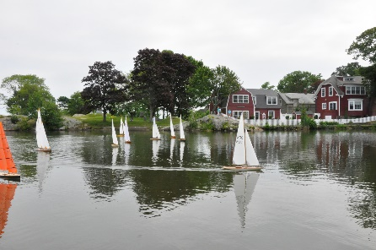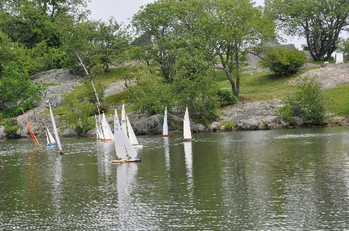
2017 American M Class
Region 1 Championship Regatta NOR
Saturday, Sept 23rd, 2017
Hosted by Marblehead Model Yacht Club
Located @ Redd’s Pond, Marblehead, MA

The MMYC American fleet, officers, and its members invite American M Class members to Historic Redd’s Pond for fun and friendly Competition

Eligibility: Must be Current AMYA & An American M Class Member. (Note American M Class Membership is One Time fee of $7 and can be paid with Registration form or at registration if not already a member.
ANY Radio Controlled 50/800 Marblehead design boat can participate if it complies with the basic rules of the American M class which are:
1, A minimum hull weight of 2.5 lbs which includes the hull, permanently mounted fixtures for sail control and mast attachment, batteries, rudder, radio, receiver, and servos. (sails, mast, keel are excluded from the 2.5 lb measurement)
2. A maximum keel length of 20” measured from bottom of the hull to the bottom of the lead.
3. For classification to one of the 4 divisions below, the hull and appendages must conform to the design requirements for the design period as defined by the existing M class rules, as well as the remainder of the approved rules for the American M Class.
All Marblehead designs are eligible to sail and will be placed in one of 4 Divisions for Award Competition based on their Design Period as follows:
Modern Division (all designs post 1995)
Classic Division ( all designs between 1970 &1995
Vintage Hi Flier (all designs between 1945 & 1970
Vintage (all designs prior to 1945)
Modern Division Designs NOTE: Redd’s Pond has Many Ledges in its sailing area, A draft of 22”, (which equates to an 18” fin when measured from the bottom of the boat to the top of the lead ballast) is sailed regularly by club members. 23” draft boats( or 19”fins) are the maximum recommended for use.

Sailing Instructions will be published prior to regatta start and will be posted on club website:  Racing will be conducted under US Sailing 2017 to 2020 racing rules of sailing and Appendix (E) Radio Sailing Racing Rules.  Racing Schedule  Saturday, Sept 23rd, 2017  08:30 Check In Begins  09:30 Skippers Meeting  10:00 Start of 1st Race  12:00 Lunch at Pond  12:45 Start of Afternoon Races  15:00 Last Race | Racing Format:  It is the intent of the Class that all boats will start together with finish positions being recorded and then converted to one of the 4 divisions for Awards Competition.  Due to pond limitations, if more than 15 boats are participating, the division with the largest number of boats will be given a separate start. If boat participation approaches 20, it is likely that a consolidation of more than 1 division will be required for the separate start  Racing will be scored using the low point system ( Appendix A of US sailing). DNS, DNF, Retired, or DSQ will be scored points for one more than number of boats entered in the event. DSQ cannot be eliminated as a throwout. Boats who are penalized under rule 30.2 or takes penalty under rule 44.3 shall be scored points as provided in rule 44.3(a)  Discards are allowed as follows  1 after race 5, 2 after race 10, 3 after  race 15, 4 after race 20, 5 after Race 25.

NOTE: Entries will be capped at maximum of 20 Boats due to the physical limitations of Redd’s Pond sailing area.

2017 American M Class Region 1 Championship Regatta
September 23rd, 2017
ENTRY FORM
ENTRY FEE $25.00 Send check payable to Marblehead Model Yacht Club to:
Craig Speck, 149 West Canton St, Boston, MA 02118. Contact Info is vim52445@yahoo.com, 617-650-2342
Entry Fee Includes: lunch, & beverages,
Registration will close on Friday at 12:00 PM:
Filled out registration form with confirmation would be appreciated prior to above Registration close. You can send it by mail or E-mail copy of the signed registration form prior to racing start. If for some reason, you forget to send it in, you may confirm your attendance by Friday Noon via email or phone call to 617-650-2342 and leave a message as to your attendance and the Model you will be sailing. This info is needed via Friday noon to provide time to order and obtain the food/beverage requirements for Saturday Lunch.
NOTE: Filled out and signed registration form must be provided to participate in the regatta.
NAME__________________________________________ADDRESS______________________________________

CITY_____________________STATE___________ ZIP_________________PHONE_________________________

EMAIL__________________________ AMYA # _______________________

M CLASS SAIL #___________________ Design ______________________

Entry Fee amount of $ 25 and if you plan to bring a guest who would like to eat lunch etc, Fee of $10 per guest. If you are not presently a member of the American M Class. You may pay the $7 one time membership fee by including an additional $7 in the amount indicated below>
Amount Enclosed ____________________________

CHANNEL/FREQUENCY - Primary_________ Alternates ______________
In consideration of your acceptance of my entry, I agree to the following conditions: 1. I hereby release the Marblehead
Model Yacht Club, its Officers, Agents and Committee from any and all liabilities for any injury to yacht or myself as a
result of my conduct. 2. I assume any risk of injury arising out of my participation. I assume all liability in the race(s), for
failure or break-age of my yacht or any of my equipment.
3. I further certify that I and my yacht is in compliance with the Eligibility requirements listed in this NOR. 4. I will honor the MMYC Corinthian spirit as described below>

SIGNTURE__________________________________DATE___________________________
MMYC Corinthian Spirit
Remember that we are always in Friendly Competition. In the event of any protested behavior which is deemed to be a breach of fair sailing, good manners or sportsmanship, the Race Director or other designated officials will protest the party or parties in accordance with RRS Part 1 Fundamental Rules 2 Fair Sailing; and or US Sailing Part 5 rule 69.1 Misconduct. Penalties available to RD and or protest committee include one turn penalty without hearing, exclusion from the race in question, or expulsion from the regatta.

